Health and Wellness App

Introduction
Project Name: Health and Wellness App
Goal: To design a user-friendly mobile app that helps users track their
daily health and wellness activities.
Role: UX/UI Designer and Developer
Tools Used: Figma, Adobe XD
Team members:
1.K MATHESH KUMAR(TL)
2.A ABIBRISCKILLA
3.L ANITHA
4.K YUVARAJ
5.P SUNDAR

Problem Statement:
Many people find hard to maintain healthy habits and track daily
wellness.Existing apps are often complex and lackpersonalization.
Users need a simple, motivating tool to monitor fitness, diet, and
sleep.A user-friendly app can help them stay consistent and improve
overall health.

User Research:
1.Research was conducted to learn how users manage their health and
wellness.
2.Most users want simple tracking for fitness, diet, and sleep.
3.They find complex apps confusing and time-consuming.

Information Architecture:
1.The app is structured for easy access to key features like Dashboard,
Activity, Nutrition, and Sleep.
2.Each section provides clear data and progress tracking.
3.Navigation is simple, with quick links to goals and reminders.

User Flow / Journey:
1.Users start by signing up and setting personal health goals.
2.They log daily activities like steps, meals, and sleep.
3.The app tracks progress and gives tips or reminder

Wireframes:
1.Basic wireframes were created for key screens like Dashboard,
Activity Tracker, and Profile.
2.They show a clean layout with clear icons and easy navigation.
3.Focus was on quick access to tracking and progress data.
4.The wireframes guided the visual design and user interactions.
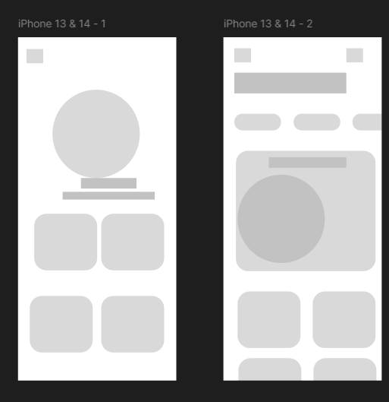

Prototype & Interactions:
1. An interactive prototype was built to show how users move
through the app.
2.It includes smooth transitions between tracking, viewing
progress, and setting goals.
3. Buttons and icons respond instantly for a seamless feel.
UI Design:
1.The UI design uses calming colors and clean layouts to promote
wellness.
2.Simple icons and clear typography make navigation easy.
3.Visual cues highlight progress and motivate users.

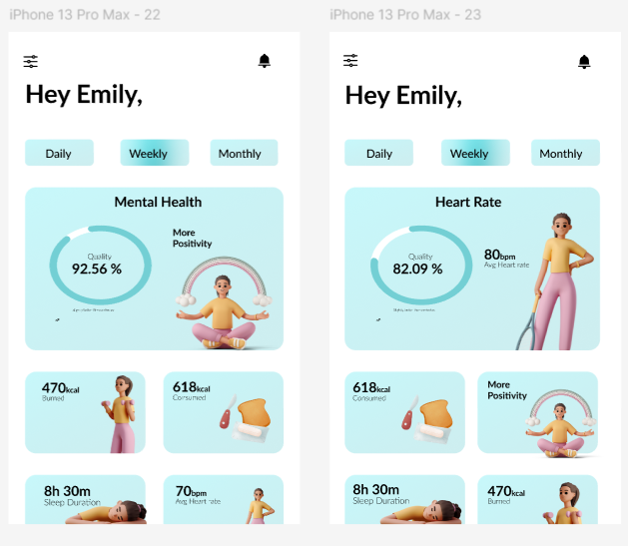

Conclusion:
1.The Health and Wellness App makes tracking daily habits simple and
motivating.
2.Its clean design and smooth flow help users stay consistent with their
goals.
3.Users can easily monitor progress and improve overall well-being.
4.The app encourages a healthier and more balanced lifestyle.

